SPECTION: Clinical Health Care Website with Health Care Analytics and Clinical Reservation Management System

Kapili, Joey Graccil

Cebu Institute of

Technology – University

N. Bacalso Avenue,

Cebu City, 6000

+63085848791

graccikapili1@gmail.com

Fernandez, Gianfranco H.

Cebu Institute of

Technology – University

N. Bacalso Avenue,

Cebu City, 6000

+639457438144

fernandez.gianfranco06@gmail.com

Barbaso, Leah V.

Cebu Institute of Technology –

University

N. Bacalso Avenue,

Cebu City, 6000

(032)261-7741 loc 110

leah.barbaso@cit.edu

**ABSTRACT**

A healthcare website is an online application that connects people using the internet. This research paper focuses on the online healthcare website that aims to develop starter clinics. The website is almost the same with the various healthcare websites on the internet but has a different feature. Many companies invested in online websites like Roque eye clinic and American eye center Philippines because of its advantageous benefits not just connect people online without going physically to the clinic but also it has many sources you can read and understand the importance of your health.

Since many eye clinic websites that are broad and starter clinics are incapable of acquiring them. Spection provides them a customized website specifically for them. What makes Spection different are the targeted starter ophthalmologist clinics and has a feature that are designed for them locally to maximize its capabilities and it’s feature of helping many patients as possible.

In conclusion only big companies that has the advantage of providing online healthcare websites to cater many patients as possible. But that makes no difference of the starter clinics because in general many patients cannot regularly check their health because the lack of time and wealth to inquire at big clinics that has an online website to reduce their time of inquiring and attending appointments.

**CCS Concepts**

• **General and reference → Document types, Surveys, and overviews • General and reference → Cross-computing tools and techniques** **• Computer systems organization → Real-time systems → Real-time operating systems • Software and its engineering → Software creation and management → Designing software • Software and its engineering → Software creation and management → Software verification and validation • Information systems → Information storage systems → Record storage systems • Information systems ➝ Database management systems ➝ Query languages ➝ Relational database query languages ➝ Structured Query Language • Information systems ➝ Database management systems ➝ Database administration ➝ Database utilities and tools • Software and its Engineering ➝ Software notations and tools ➝ General programming languages ➝ Language features • Software and its Engineering ➝ Software notations and tools ➝ General programming languages ➝ Context specific**  **• Software and its Engineering ➝ Software organization and its properties ➝ Contextual software domains ➝ Operating systems ➝ Communications Management ➝ Input/Output • Software and its Engineering ➝ Software organization and its properties ➝ Contextual software domains ➝ Operating systems ➝ Communications Management ➝ Message passing • Information systems ➝ Database management systems ➝ Database design and models ➝ Entity relationship models • Information systems ➝ Database management systems ➝ Middleware for databases ➝ Application servers • Information systems ➝ Database management systems ➝ Middleware for databases ➝ Database web servers**

**Keywords**

Optometrist; Eye Specialist; Appointment; Consultation; Messenger; Healthcare; Analytics; Chatbot; SMS; SMS Reminder; Chartjs; Twilio; Django; Python; Django Python Web Framework

1. **INTRODUCTION**

Internet are knowledgeable nowadays, many people even from 70’s, 80’s uses internet. It is a modern software to connect people anytime and anywhere. Internet can be useful to almost anything in today’s generation. Specially appointments where you can access the internet and set your schedules. The pandemic allowed hospitals to increase their facilities to cope with the situation. Public hospitals focus their efforts on preventive and primary care. They are also taking the lead in educating the public on health issues. The Private hospitals, on the other hand, focus on specialized care for cardiovascular diseases, cancer, pulmonology, ophthalmology, orthopedics and etc. [1]. In the Philippines, private treatment typically implies more comfort for patients. When there are fewer individuals seeking care, it is typically easier to get treatment. Furthermore, private facilities offer more modern equipment. It is not, however, required to go to a private institution to be treated by an English-speaking doctor. If you seek treatment at a private clinic, ensure sure you either have the finances available or that your health insurance carrier will cover your charges [2].

Spection is a website for individuals who provide patient care and have experience in managing clinical healthcare services to accommodate patients concern and inquiries. This website is design to connect patients and doctors online. There is no need for taking a leave in your daily work just to book your schedule. Everyone can be accommodated from children to adults.

Our eyes are one of the critical assets giving us motivation and hope to perform daily challenges of living.

It is essential to accommodate as many patients as possible when having a health clinic. It is vital to give them notice of what they’re experiencing and knowledge about their symptoms. The doctor needs to communicate to them as much as possible about the possible immediate cure to avoid losing the patient’s vision.

Here in Cebu City, Philippines most of the people here ’orks in the city with no time to have check their health. Which means they are vulnerable to damaging their body. Kids, Teens, Adults can already experience eye problems with no time to be checked by professionals. Spection will provide a convenient appointment reservation and diagnostic test for the patients to avoid hassle on taking time to go physically to the clinic. On the other hand, Spection will store data and implement a graphical trend for the health records which gives the doctors knowledge of the health records of their patients.

Spection is a web-based application. It carries out the function of maintaining patients’ medical details. The users can add patients, enter medical history about them, schedule an appointment for medical checkups, enter diagnoses for all appointments, and generate reports. As it is a web-based application, users can access it from anywhere at any time from desktops and mobiles. So doctors need not waste their time by writing the details on papers and storing papers by maintaining proper order, which may increase the probability of losing data. Also, it saves time on booking appointments for patients since we can book appointments online even during our free time instead of going to a particular place to book appointments for our loved ones in person. We have provided a login facility to users and an admin panel to maintain different user accounts like the doctor, receptionist, etc. Data privacy is considered an utmost priority so that no one can misuse the data stored in our database.

This research report details all of the stages of the investigation. There are five significant chapters: Introduction, which provides an overview of the project; Evaluation of Related Software, in which each of the researchers provides an in-depth review of one related software of the system and tabulates a matrix of comparison to highlight the benefits of each software among others; Methodology, in which the researchers explore the inspiration, ideation, and methodologies used in the construction of the system; Analysis; and Discussion.

1. **REVIEW OF RELATED SOFTWARE**

The following applications have similar features to the proposed project. Each application is reviewed based on the proposed project Spection.

**2.1 Eduardo Besser, MD**

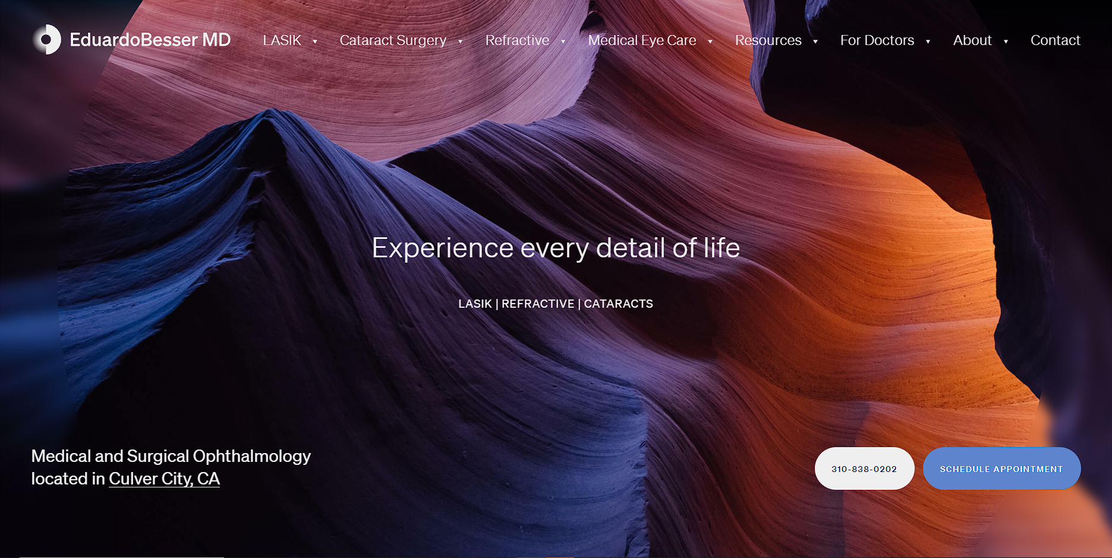

**Figure 1: Eduardo Besser Main Web Page**

The Eduardo Besser, MD website offers an intuitive menu design. It includes information that ophthalmology patients frequently look for on website. Patients can quickly find details about the office’s services, forms, and staff.

**2.2 Advanced Vision Care**

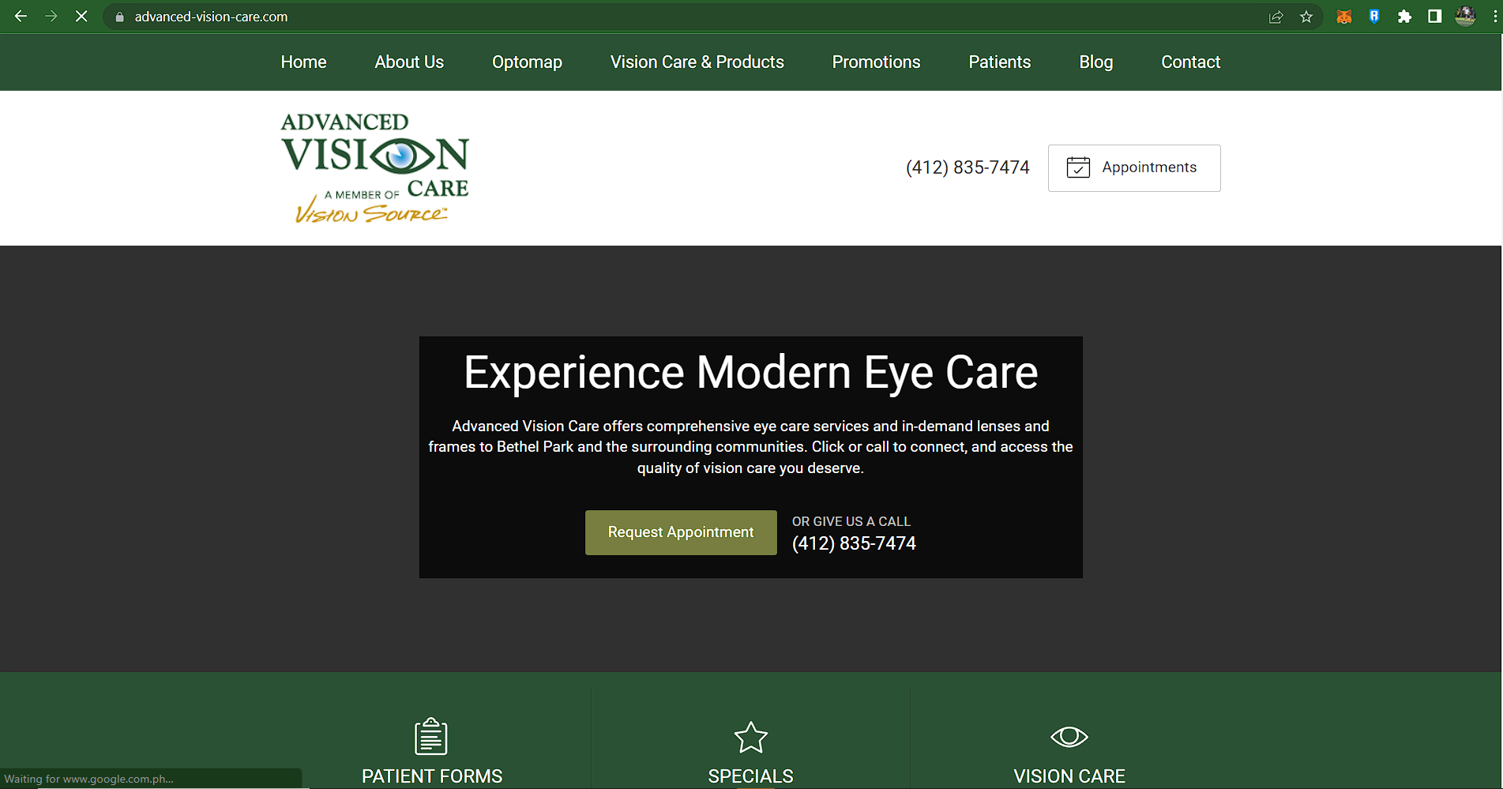

**Figure 2: Advanced Vision Care Main Web Page**

Advanced Vision Care’s website includes important messaging about business hours at the top of the page. Other essential features include user-friendly contact forms, an appointment calendar, social media buttons and an updated blog. The site loads quickly on mobile and desktop devices.

* 1. 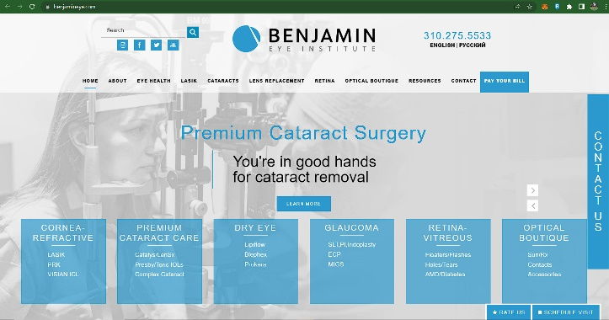**Benjamin Eye Institute**

**Figure 3: Benjamin Eye Institute Main Web Page**

The Benjamin Eye Institute site is easy to navigate. Patients can learn more about the eye center by clicking the hamburger menu icon. The menu provides quick access to information about services, eye health and a blog. Patient resources on the website include instructions, maintenance tips, contact lens information and forms.

**2.4 American Eye Institute**

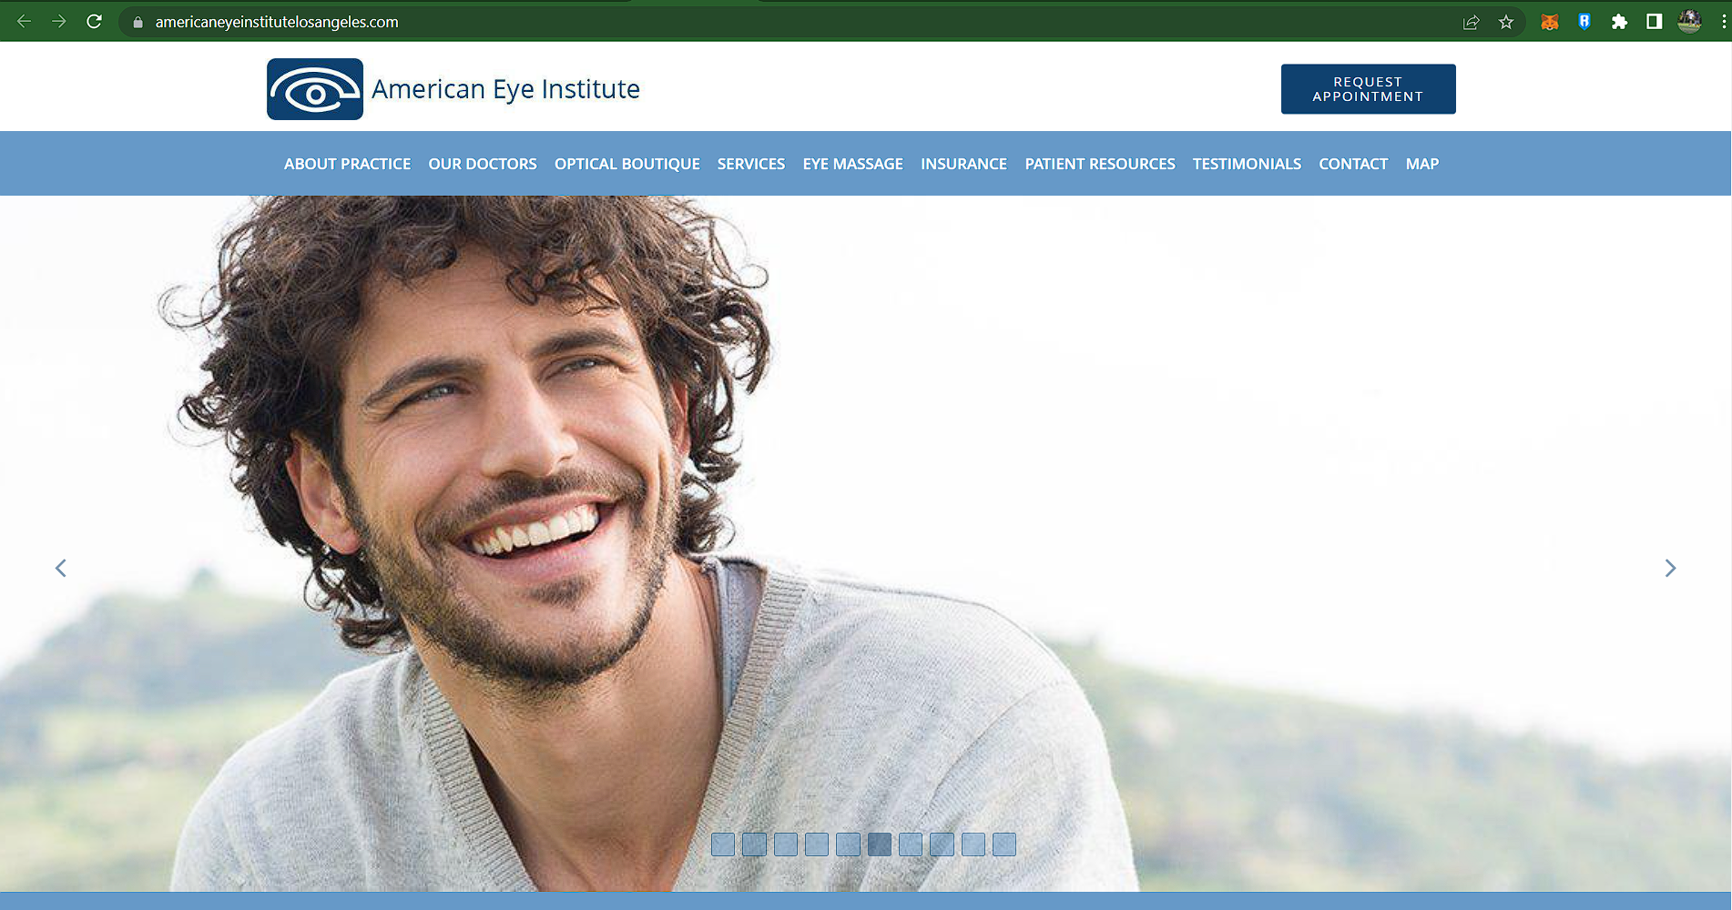

**Figure 4: American Eye Institute Main Web Page**

The American Eye Institute’s website provides a few ways for patients to request appointments. They can schedule a virtual visit online or request an in-person appointment by phone. The site includes Yelp reviews from patients. These reviews build trust with site visitors. This site includes information about American Eye Institute’s on-site eyeglasses boutique.

**2.5 Maloney-Shamie Vision Institute**

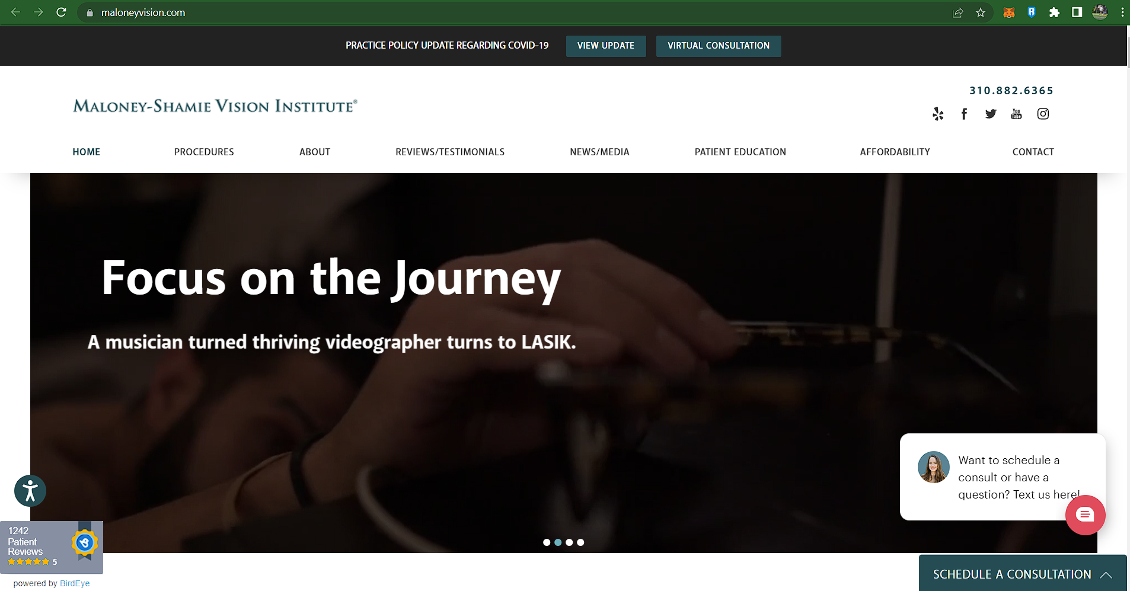

**Figure 5: Maloney-Shamie Vision Institute Main Web Page**

The Maloney-Shamie Vision Institute’s website has a responsive design. The homepage header features videos and lively pictures. It includes a list of news and media outlets that have featured this eye center. Patients can book a virtual consultation online or chat with a representative during business hours. Online patient education information includes online books and educational videos.

**2.11 Matrix of Comparison**

The table below shows the matrix of comparison. The matrix of comparison compares which features are present or missing in a particular application. This will provide a quick visualization of the advantages between the reviewed related software.

|  |  |  |  |  |  |  |
| --- | --- | --- | --- | --- | --- | --- |
| Features | SPECTION | E. Besser | AV Care | Benjamin Eye | American Eye | MS Vision |
| Consultations | ✔ | ✔ | ✔ | ✔ | ✔ | ✔ |
| Appointments | ✔ | ✔ | ✔ | ✔ | ✔ | ✔ |
| Patient Login Portal | ✔ |  |  |  |  |  |
| SMS Reminder | ✔ |  |  |  |  |  |
| Live Chat Support | ✔ |  |  |  |  | ✔ |
| Timetable | ✔ |  | ✔ | ✔ |  | ✔ |
| Raw Data Export | ✔ |  |  |  |  |  |
| Reviews | ✔ | ✔ |  | ✔ | ✔ | ✔ |

**Table 1. SPECTION Matytrix of Comparison**

**3. Methodology**

This Chapter discusses the Observation, assumption and methodological approach of how the system has been developed. Also, the system prototype can also be found in this chapter.

**3.1 Observation**

Most of the small or starter clinics handling their data by hard copies and does not have a computerize system of managing their data. As a clinic that operates 7 days a week and cater several patients daily some. Having this operation daily a result to data inaccuracy because of the lack of data analysis system.

**3.2** **Assumption**

The researcher strongly believes that having a computerized data management can improve the clinic daily duty. Having this system upgrades the management and providing the patients a convenient access to the clinic with the website that has many features like Appointment bookings, Patient Login, and etc. [9] According to an article, The Pros and Cons of Health Websites. There is a lot of sources that you can find on internet that you can relate with the personalized communication of the clinics doctor.

**3.3 Methodological Approach**

The researchers first conduct a survey to gather information about the probable pain points. After gathering the data, the researchers then proceed to develop the system.

*3.3.1 Research Instrument*

The researcher conducted usability questionnaire that consist of yes or no, multiple choice, checkbox, Likert scale questions using the Microsoft forms platform.

**Table 2. Survey Questionnaire**

|  |  |  |
| --- | --- | --- |
| **No** | **Question** | **Type** |
| 1 | Have you gone to any healthcare related sites? | Yes/No |
| 2 | How often do you visit a clinic annually? | Multiple Choice |
| 3 | Which services do you manage to contact for inquiries and concerns to your healthcare provider? | Checkbox |
| 4 | In urgent situations you were able to schedule timely visit? | Likert Scale |
| 5 | Keeping you informed if your appointment time was delayed? | Likert Scale |
| 6 | How would you rate the difficulty in asking concerns about your health to your healthcare provider? | Likert Scale |
| 7 | How did you find the experience of booking appointments? | Likert Scale |
| 8 | How do you describe the difficulty on queuing to the line in ongoing clinical checkups? | Likert Scale |
| 9 | How much time would the you wait for your accommodation in reception area? | Numeric |
| 10 | How do you rate the difficulty in tracking your medications, orders, or your payments? | Likert Scale |
| 11 | Where they able to answer all your questions? | Likert Scale |
| 12 | How much time would you finish in answering pre-assessment survey forms/Covid-19 inspection checklist form? | Multiple Choice |
| 13 | How likely would you use a website for a clinic? | Likert Scale |

Table 2 above shows the questions asked in the survey. The survey was dispersed via google forms and provided with the pdf file of to Spection protype. The questionnaire of the survey is acquired through usability.gov to measure the usability of Spection which are composed of 10 statements that lets the user rate, refer from table 2 for more information about the questionnaire. The researchers make use of the System Usability Scale which is a reliable tool for measuring the usability of wide varieties of products and services including hardware, software, mobile devices, websites, and applications.

*3.3.2 Research Environment*

The research respondents where eye concerned patients that uses other online health clinics. The researchers found out that it is a time consuming to physically appoint their bookings and be scheduled to other day while they have daily work or duty. They prefer to take online inquiries to save time and communicate the clinic than to proceed to the clinic and have their scheduled or inquiries delayed.

*3.3.3 Research Design*

The researchers interpreted and evaluated the data collected from the respondents using descriptive statistics. The data was processed by converting worded responses to some questions into numerical equivalents. The results were then visualized into graphs and transformed into numerical ratios using Microsoft Excel.

**Figure 6. Data Gathering and Analysis Process**

**3.4. System Design and Specification**

After gaining insights from the survey data, the researchers went on to brainstorming session. It was obvious that the present programs needed to be improved. The team held brainstorming meetings to come up with ideas since the project's concept is related to the clinical healthcare service management. Each researcher was tasked with proposing a viable solution or feature for the project system's development. Microsoft Teams was used to provide six-hour online brainstorming sessions twice a week.

Following a comprehensive analysis, the researchers developed SPECTION.

**3.5. System Design and Specification**

This section shows Model View Controller (MVC) Architecture of the project, its framework and applied application programming interfaces (APIs) and the Unified Modeling Language (UML) diagrams of the system.

*3.5.1. MVC Architecture*

MVC pattern is a Product Development Architecture. It solves the traditional approach’s drawback of code in one file, i.e., that MVC architecture has different files for different aspects of our web application/ website. This difference between components helps the developer to focus on one aspect of the web-app and therefore, better code for one functionality with better testing, debugging and scalability. [8] The Model is the element of the web-app which functions as a mediator between the internet interface and the database. There are instances when the application may merely collect data in a specific dataset, and deliver it to the view (UI component) without having any database. The Model is the component which contains Business Logic in Django architecture. View is primarily the User Interface of the web-application and comprises the components like HTML, CSS and other frontend techniques. This component comprises the UI logic in the Django architecture. View generates from the Models component, i.e., the content comes from the models. The primary purpose of the controller is to choose a view component according to the user interaction and also apply the model component. The controller as the name says is the key control component. What it means is, the controller manages the user's input and picks a view for each unique user.



**Figure 7. MVC Architecture of SPECTION**

Once a user submits a request through a browser or via a mobile device, a router, using urls.py would transport the request to the controller. The controller would then make the request to the model in which the data required would be obtained from the database which would be delivered back to the controller afterwards. The controller would then send the received data to the view which would bring back the appropriate user interface given the data. By that time, the controller would have sent the result to the browser window or device.

*3.5.2 Frameworks and APIs*

The project was built by Django Framework for the back-end and bootstrap for the front-end. Bootstrap is a potent front-end framework used to create modern websites and web apps. It's open-source and free to use, yet features numerous HTML and CSS templates for UI interface elements such as buttons and forms. Bootstrap also supports JavaScript extensions. While Django is a high-level Python web framework that enables rapid development of secure and maintainable websites. Built by experienced developers, Django takes care of much of the hassle of web development, so you can focus on writing your app without needing to reinvent the wheel. The proposed section project has also an integration and analysis features, like SMS reminder enables the management to remind a message. Using TWILIO for SMS feature, the tool used is a programmable mobile application that enables digital relationships over messaging and voice to improve sales efficiency and outcomes. Integrate the app with any customer database and start building meaningful relationships with customers. Implementing Graphical Charts for showing visualization and interpretation of results design pattern uses the Chart.js tool, an open source html5 chart for the website that can integrate charts to be media responsive and has enhance visualization. The timetable allows the user to keep track of which days they want to be scheduled, Appointment Booking for patients can connect with doctors, Raw data Export enables the management to share specific aspects of the studies, Chat support uses a real-time chat window and chat with either a chatbot or a live person to answer patient queries. Chat support uses Messenger Plugin able to access in Facebook messenger chat and integrate the website to provide a messenger chat head.

*3.5.3 Use Case Diagram*



**Figure 8. SPECTION Use Case for Clinical Operations Management**



**Figure 9. SPECTION Use Case for Management on Data Sales, Database Size and News Update**



**Figure 10. SPECTION Use Case for Patient Dashboard Interaction**

**Figure 11. SPECTION Use Case for User Interaction and Navigation**



*3.5.4. Class Diagram*

The Class Diagram of SPECTION (Figure 12) shows the respective attributes and data types of classes (refer to Appendix C for a detailed view).



**Figure 12. SPECTION Class Diagram**

*3.5.5. Entity Relationship Diagram (ERD)*

The Entity Relationship Diagram of SPECTION (Figure 12) shows the relationship between the User entities and of the system (refer to Appendix D for a detailed view).



**Figure 13. SPECTION Entity Relationship Diagram**

**3.6 System Prototype**

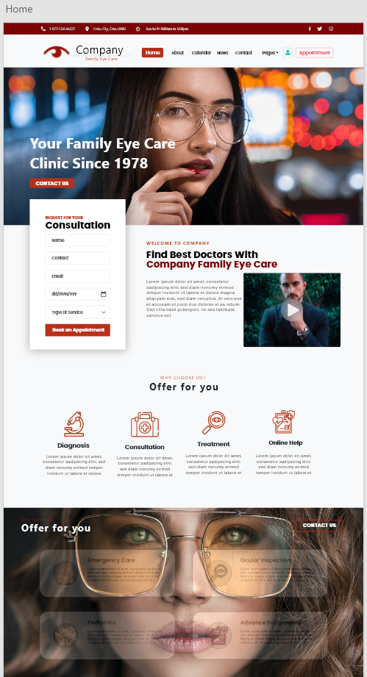This portion exhibits the system’s prototype in both web and mobile version. The parts of the system are all based on the results from the initial demonstration of project representation testing. The succeeding illustrations below depict the working prototype designed and built by the researchers however it is still a work in progress and is subject to modifications.

**Figure 14. Landing Page**

It is most typically viewed by visitors who are not otherwise aware of the website. this contains convenient navigational tools that will enable users to navigate themselves to the part of the site that they desire to be in.

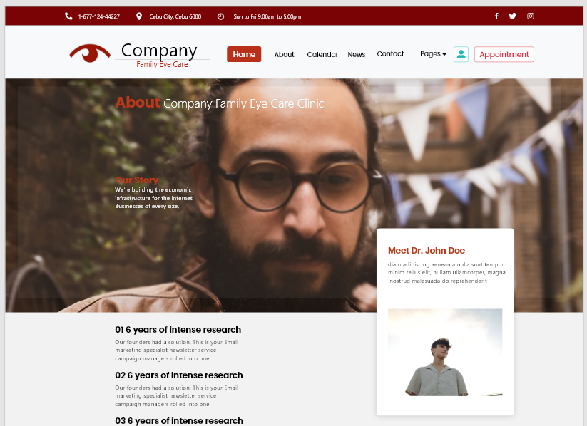

**Figure 15. About Page**

About us page contains Spection's Mission and Vision of the clinic and the story behind how the researchers manifestation of the idea and developed into a website.

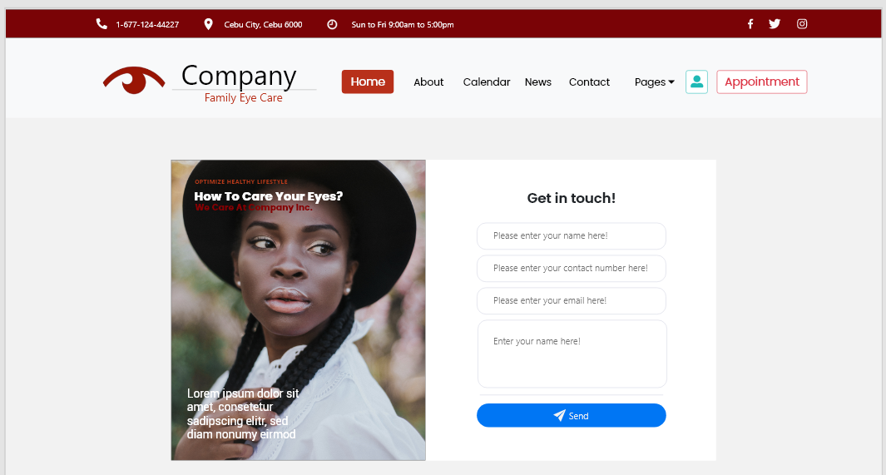

**Figure 16. Contact Page**

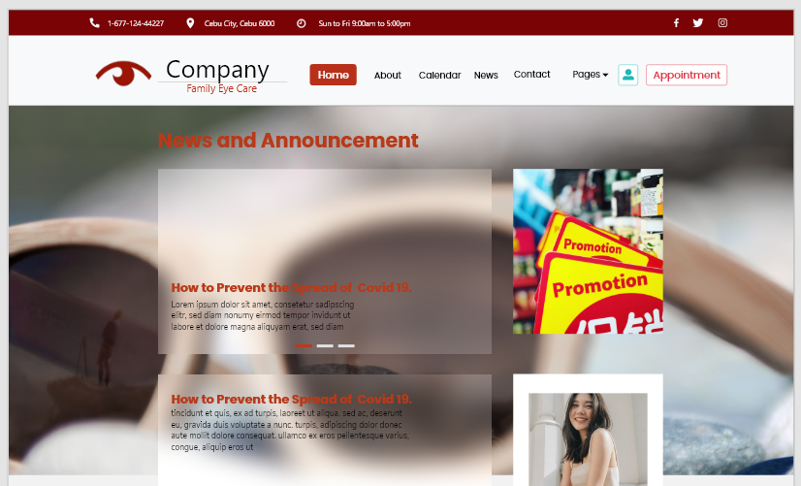Contact Us Page, contains the contact information of the clinic and provides a chatbot that ease your communication with the clinic.

**Figure 17. News and Announcement Page**

News and Announcement Page, the clinic provides daily news and clinic announcement for the patients. It is where daily trivia or other health related sources from other verified online health advisors are posted.

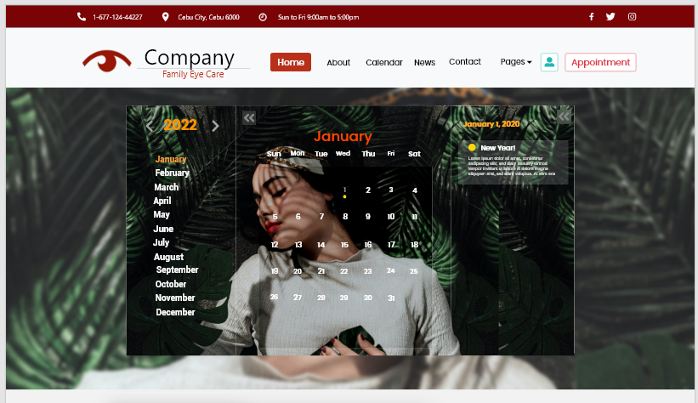

**Figure 18. Calendar’s Page**

Calendar Page contains the user calendar together with its features to book their appointments based on the availability of the clinic.

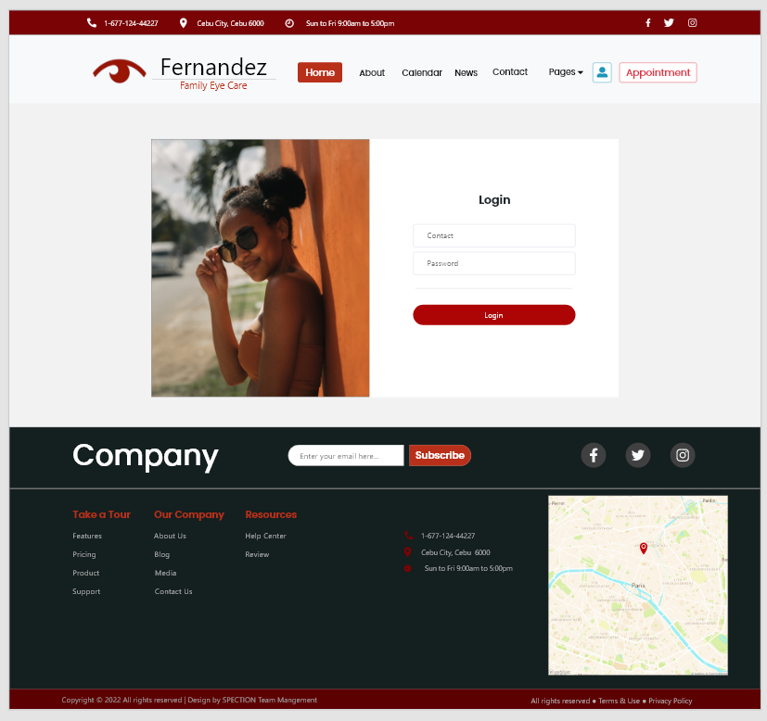

**Figure 19. Login Page**

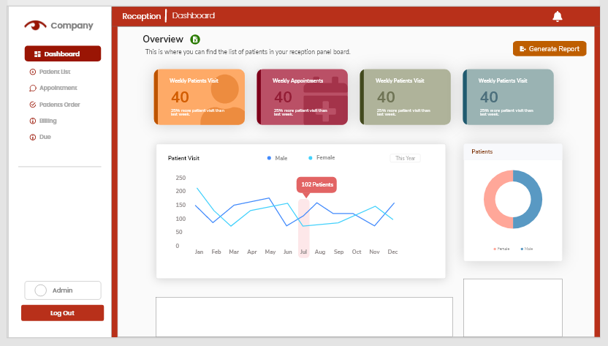Patient Login page, it is where the patients logged in to the website as a clinic's patient user after the receptionist provides the patients registration.

**Figure 20. Staff Dashboard Page**

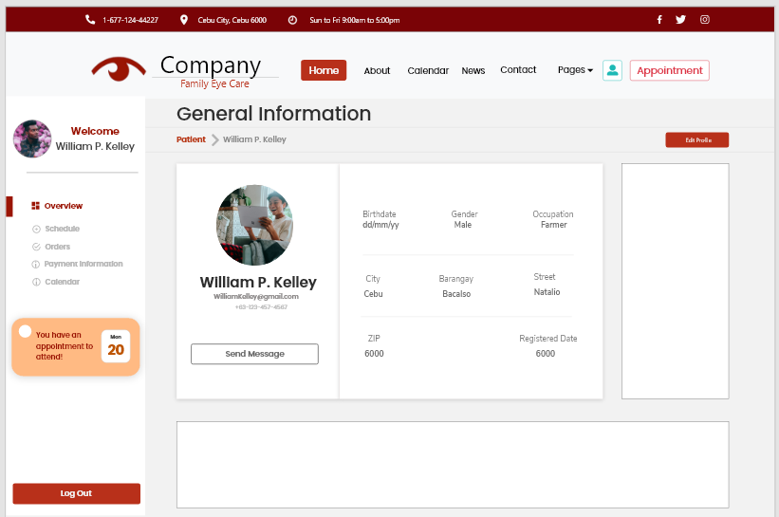Staff Dashboard Page contains the features of the clinics graphical overview and navigation pages to patient list, appointments, patients order, billing and dues.

**Figure 21. Patient Portal Page**

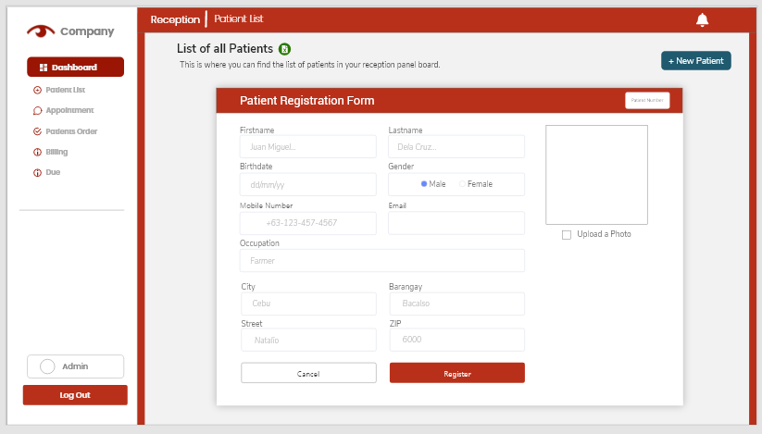Patients Portal Page contains the patients’ profile and overview of the account. This page shows the list of schedule, payments and history and also information of the order of the user.

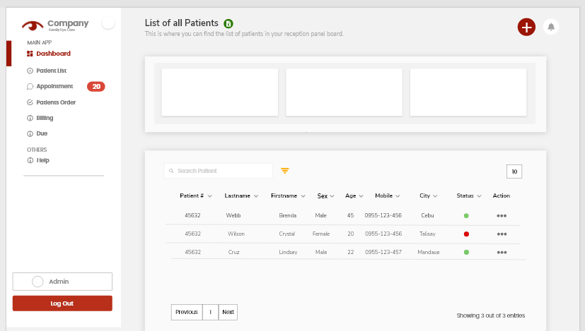**Figure 22. Patient Registration Form**

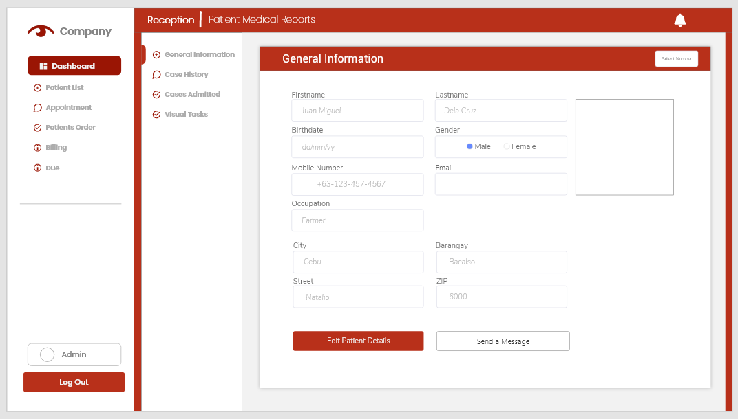**Figure 23. List of Patient Page**

**Figure 24. Patient Case Information Page**

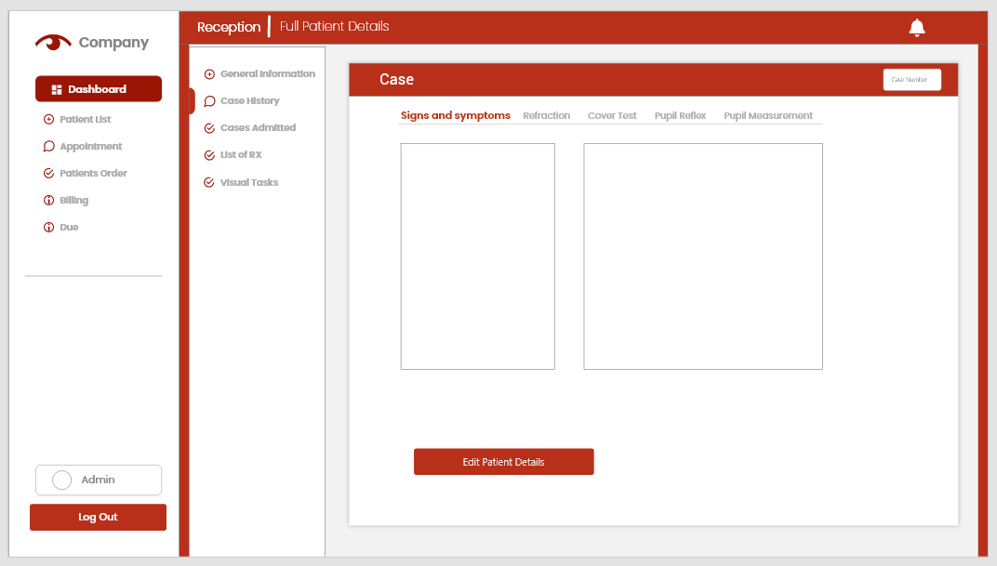Doctor's Patient Case Information Page contains the confidential patient’s diagnosis and case history records where only the doctor can access the page.

**Figure 25. Patient Case Information Form**

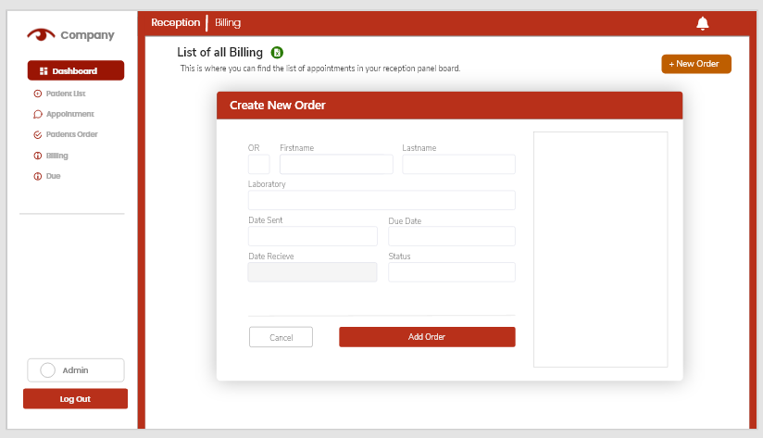**Figure 26. List of Appointment Page**

**Figure 27. Billing Form**

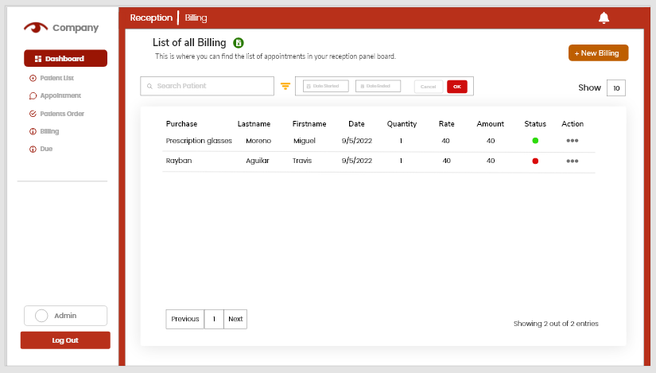The Staff Invoice-Form Page contains all the list of all billing dates and can be added by the reception.

**Figure 27.1 List of Billing Page**

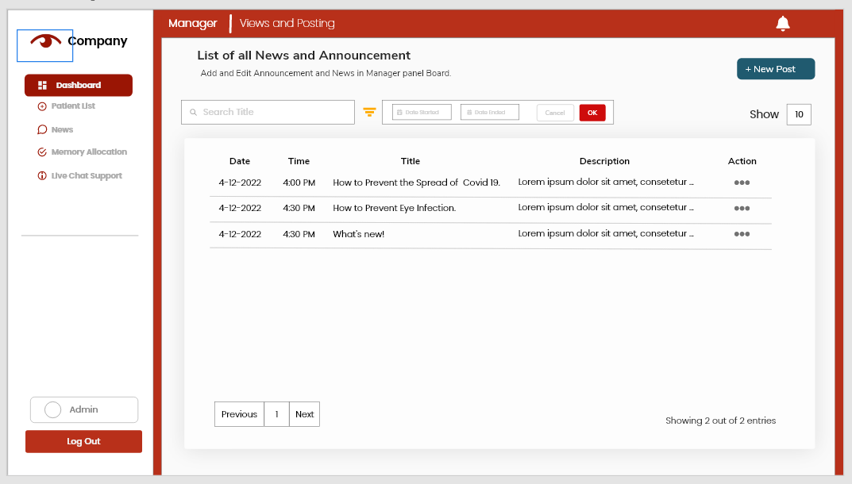

**Figure 28 List of Posting Page**

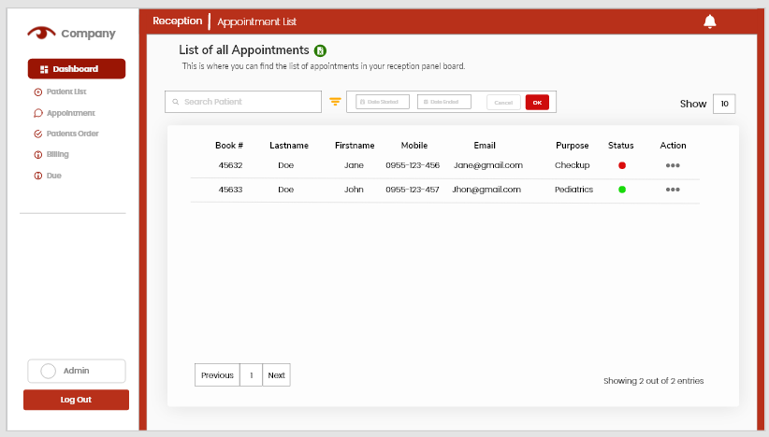Staff Views and Posting Page, it is where the staff edit and post the News and Announcement page on daily basis and the clinics promotions.

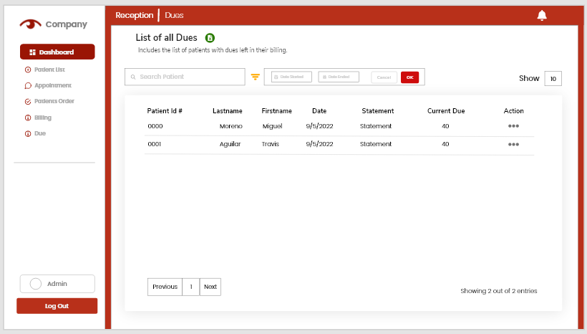

**Figure 29. List of Dues Page**

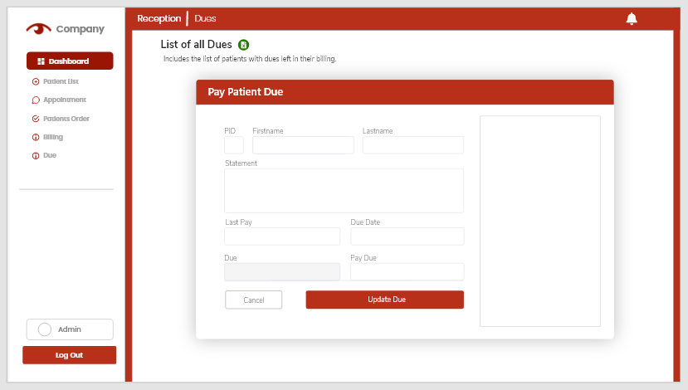The Staff Due-Form Page, Contains the list of all due dates information and can be updated.

**Figure 30. Due Form**

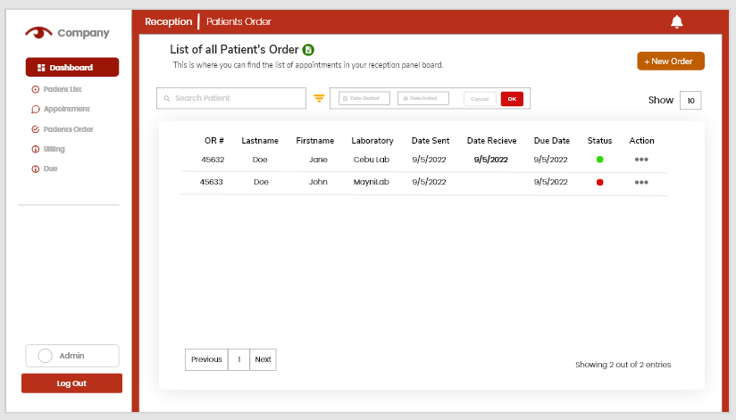Dues are automatically created when there is amount that not yet to be paid in creating a billing form in the Billing section. Only the clinical staff are ones who manage and updates the view.

**Figure 31. List of Patients’ Order**

Displays the List of Order to be sent to Laboratory and receive the order by the specified patients.

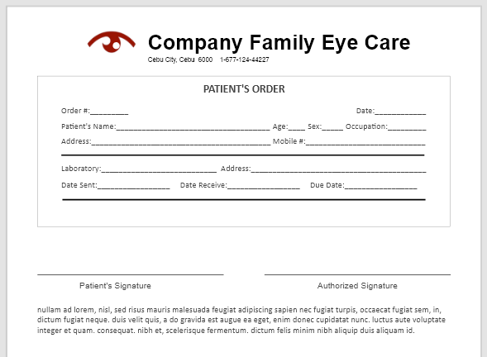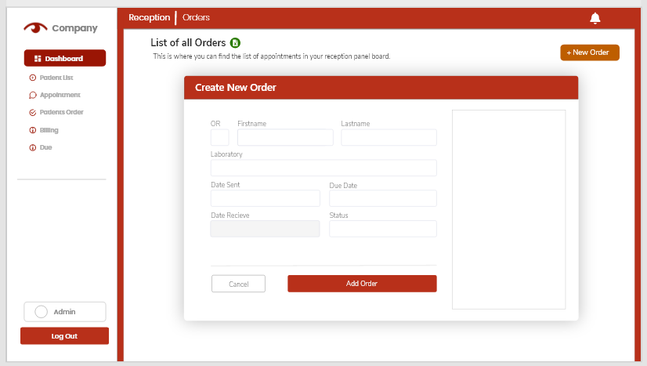**Figure 32. Patient’s Order Form**

Creating a new Order is done through a floating modal by clicking the Add New Order button.

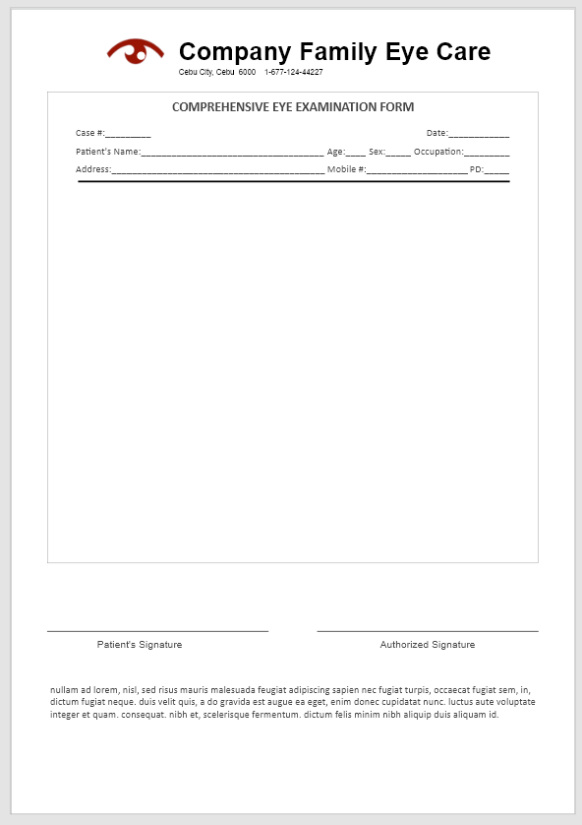

**Figure 33. Print Sample Form**

Print patient, orders, invoice etc. details able for the user to have a copy for the record to be used for medical, personal or educational purposes.

**Figure 34. Print Sample Form**

Printing the data of the form is done by clicking Print button existing on the Pages.

**4. RESULTS, ANALYSIS AND DISCUSSION**

This section presents the findings of the surveys completed from the beginning of the project and also the results of System Usability Scale survey. This chapter provides the extensive evaluation and discussion of the results based on the data obtained from the respondents.

**4.1 Respondents Profile**

The survey sums up to 10 respondents as shown at the table below (table 2). They were grouped based on their gender as resulted to a total of seven (8) male respondents that is 73% of the survey population and three (3) female respondents, 27% of the population.

|  |  |  |
| --- | --- | --- |
| **Gender** | **No. of respondents** | **Percentage** |
| Male | 8 | 73% |
| Female | 3 | 27% |
| Total | 11 | 100% |

**Table 3. Respondents Grouped According to Gender**

**4.2 System Usability Scale**

During the test run of the website the users are then provided with the SUS questionnaire using Microsoft forms based on their perspective using the Spection website to determine if the system met its requirements. With total population of 11 respondents mentioned above (3.6 Respondents Profile) are also the tester of the system which are all composed of capstone 1 students.

The result showed (45.5%) of the population strongly agreed to use the system frequently, (45.5%) agree and 9.1% are neutral with their decision. The respondents also scale the complexity of the system, (27.3%) of the population strongly disagree of finding the inconsistency of the system while (54.5%) disagree, (9.1%) find it neutral and (9.1%) strongly agree.

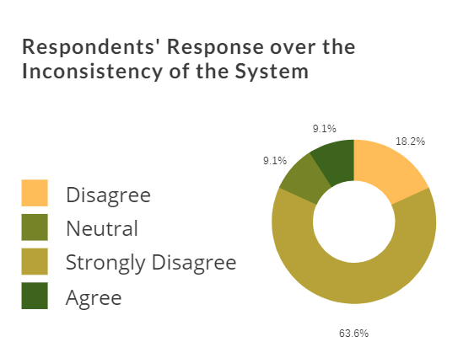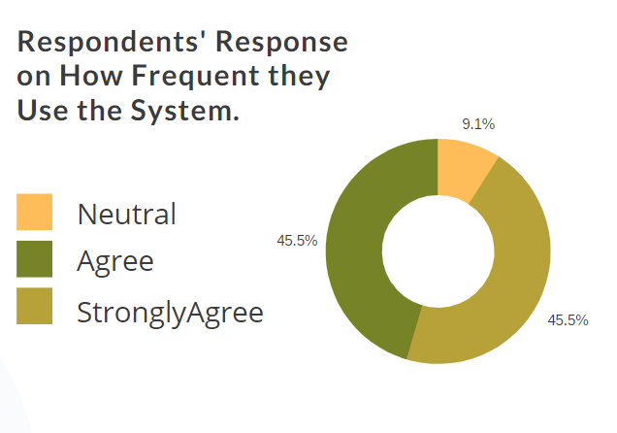

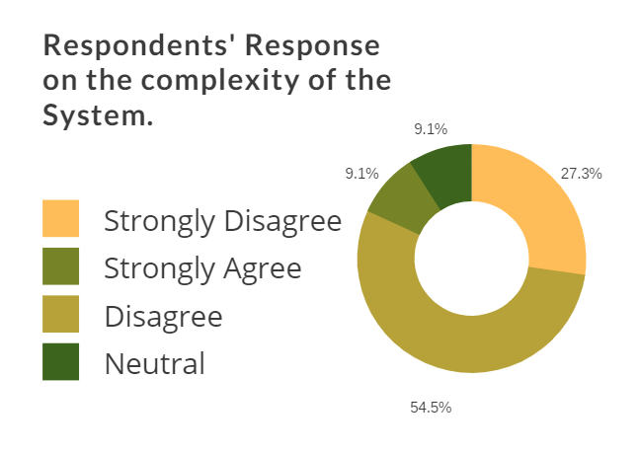**Figure 35. Usage Frequency of the Respondents**

**Figure 36. Complexity of the System**

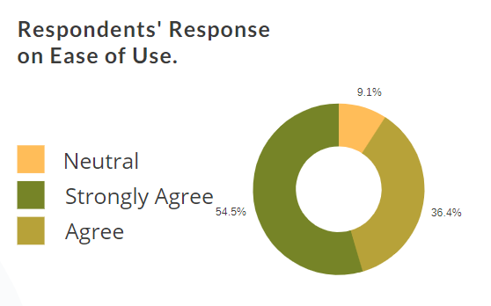The system consistency shows (54.5%) of the population strongly agree of using the system easily, (36.4%) Agrees and (9.1%) are neutral.

**Figure 37. Ease of Use**

As a user specially introduced to a new website some needed assistance of handling the interface. Although the result shows (9.1%) agreed themselves finding a support technical person to be able to use the system, (18.2%) are neutral, (27.3%) disagree, majority of the respondents which are (45.5%) who strongly disagree more than half considering the (27.3%) who disagree who does not need a technical support person to use the website. The (9.1%) of the population also agree and (27.3%) are neutral of needing a lot of things before they could get going with the system. (45.5%) are who strongly disagree and (18.2%) disagree.

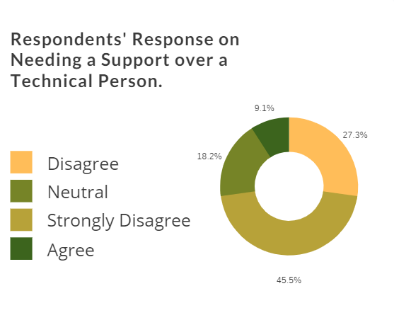**Figure 38. Inconsistency of the System**

**Figure 39. Needing a Technical Support**

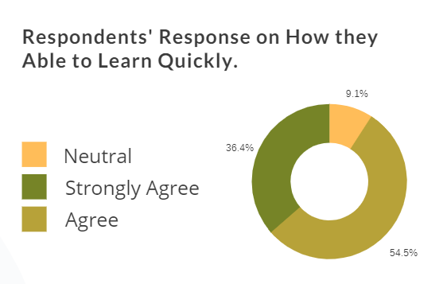The system shows how integrated it is to use resulting of a positive scale. Both users who agree and strongly agrees are (45.5%) of the populations and (9.1%) are neutral.

**Figure 40. Able to Learn Quickly**

The consistency scale of the system although with the number of respondent population there are (9.1%) who thought the system’s inconsistency and (9.1%) are neutral, (18.2%) who 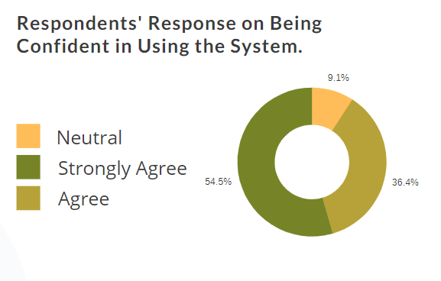agreed and (63.6%) who strongly agreed there is not much 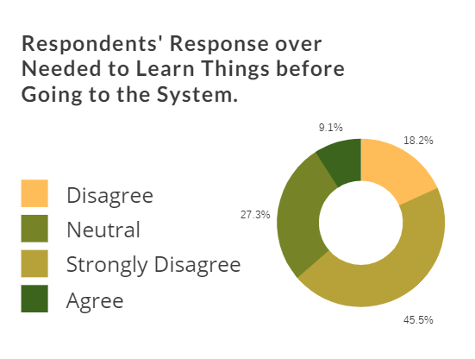inconsistency of the system.

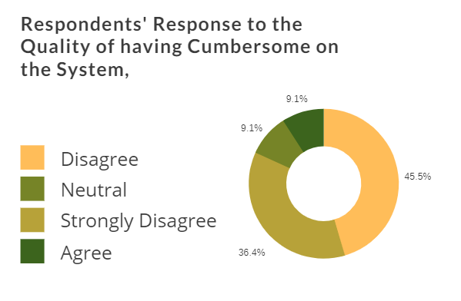**Figure 41. Respondents Learning Curve**

**Figure 42. Quality of having Cumbersome**

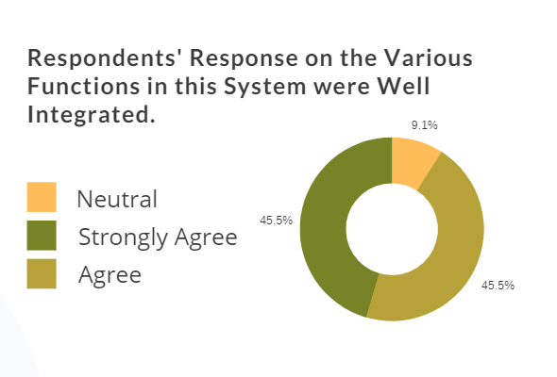The system also has another positive scale result of how the user can learn with the system very quickly. (54.5%) who agree, (36.4%) who strongly agrees and (9.1%) are neutral. Although (9.1%) of the population find it very cumbersome the system to use (9.1%) are neutral but majority are (45.5%) who disagree and (36.4%) who strongly disagree.

**Figure 43. Response on Integration**

Lastly the scale of how confident the users using the system. (54.5%) of the population feel Very confident and (36.4%) who scaled confident and (9.1%) are neutral.

**Figure 44. Respondents’ Level of Confidence**

With the result of the survey the researchers then analyzed by calculating the system usability system scale score. Using the formula shown below (figure 17). The values are 5- strongly agree, 4 – agree, 3- neutral, 2- disagree, 1- strongly disagree.

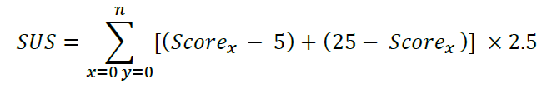

**Figure 45. System Usability Score Equation**

Considering The Odd questions are subtracted by 5 and 25 are subtracted by sum of all even questions. The sum of both even and odd questions are then multiplied by 2.5.

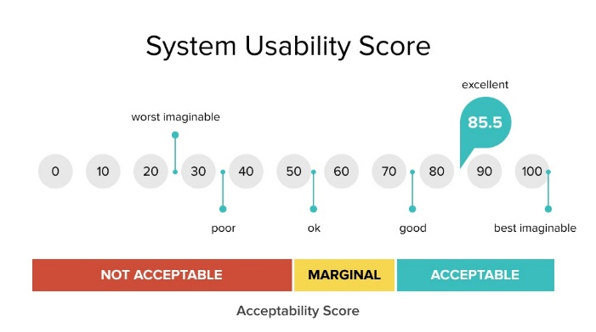

**Figure 46. SUS Acceptability Score**

After the researchers calculated the system usability scale score, the highest scale score attained is 100, and the lowest is 55. The total average score is 78.5, as the figure shown above (18. SUS Acceptability Score) the score is labeled acceptable.

In conclusion the System usability scale score is resulting to acceptable level. Although it scaled about good, the system needs maintenance and improvement. Especially for the UI interface design since the system is about health websites specifically for eye concerned patients. In general, the system satisfies the user, it is user friendly that cater the need of the user.

**5. REFERENCES**

|  |  |
| --- | --- |
| [1] | International Trade Administration, "Philippines - Healthcare," International Trade Administration | Trade.gov, 2022. [Online]. Available: https://www.trade.gov/country-commercial-guides/philippines-healthcare. [Accessed 30 May 2022]. |
| [2] | International Citizens Insurance, "Healthcare in the Philippines," 20 May 2022. [Online]. Available: https://www.internationalinsurance.com/health/systems/philippines.php. [Accessed 30 May 2022]. |
| [3] | E. Besser, "Eduardo Besser, MD: Opthalmologist," 2022. [Online]. Available: https://www.eduardobessermd.com/. [Accessed 30 May 2022]. |
| [4] | Advanced Vision Care, "Optometrist in Bethel Park PA," 2021. [Online]. Available: https://advanced-vision-care.com/. [Accessed 20 May 2022]. |
| [5] | Benjamin Eye Institute, "About: Benjamin Eye Institute," 2019. [Online]. Available: https://www.benjamineye.com/about/. [Accessed 30 May 2022]. |
| [6] | American Eye Institute, "American Eye Institute: Cornea Specialists," 2022. [Online]. Available: https://www.americaneyeinstitutelosangeles.com/. [Accessed 30 May 2022]. |
| [7] | Maloney-Shamie Vision Institute, "Best eye doctor Los Angeles: Maloney-Shamie Vision Institute," 2022. [Online]. Available: https://www.maloneyvision.com/about/. [Accessed 30 May 2022]. |
| [8] | DataFlair, "Django Architecture - 3 major components of MVC Pattern," 21 June 2021. [Online]. Available: https://data-flair.training/blogs/django-architecture/. [Accessed 30 May 2022]. |
| [9] | Canopy Health, "The Pros and Cons of Health Websites," 5 December 2017. [Online]. Available: https://www.canopyhealth.com/the-pros-and-cons-of-health-websites/. [Accessed 30 May 2022] |
| [10] | Roque Eye Clinic, "ROQUE Eye Clinic | Eye.com.ph," 6 January 2022. [Online]. Available: https://www.eye.com.ph/. [Accessed 30 May 2022] |

1. **Appendix**

**Appendix A**

Survey Questionnaire

**Consent for Participation**

This survey is designed to collect data from individuals who is involve in providing patient care and in managing clinical healthcare services. The goal of this survey is to familiarize and analyze clinical healthcare management operations in order to identify potential key challenges, probable pain points and provide a solution that our team has developed: *SPECTION Clinical Health Care Website with Health Care Analytics and Clinical Reservation Appointment System*.

By continuing, you have:

a. Accepted to participate in this survey and have agreed to answer honestly;

b. Understood the purpose of the survey, and that you have the opportunity to ask questions to the researchers to your satisfaction;

c. Understood that the answers are confidential and are only used for the purpose of this research study.

Thank you

1. **Patient’s Survey**

* Have you gone to any healthcare related sites?

Yes No

* How often do you visit a clinic annually?

Per Week

Every Month

Occasional

I don’t visit at all/

* Which services do you manage to contact for inquiries and concerns to your healthcare provider? Select all that apply.

Email

SMS/Text

Online

Personal

Others: Please Specify ___________

* In urgent situations you were able to schedule timely visit?

Definitely Not Probably Not Probably Probably Definitely Definitely

* How would you rate the difficulty in asking concerns about your health to your healthcare provider?

Very Difficult Difficult Neutral Easy Very Easy

* How did you find the experience of booking appointments?

Very Difficult Difficult Neutral Easy Very Easy

* How do you describe the difficulty on queueing to the line in ongoing clinical checkups?

Very Difficult Difficult Neutral Easy Very Easy

* How much time would the you wait for your accommodation in reception area? ________
* How do you rate the difficulty in tracking your medications, orders or your payments?

Very Poor Poor Fair Good Excellent

* Where they able to answer all your questions?

Definitely Not Probably Not Probably Probably Definitely Definitely

* How much time would you finish in answering pre-assessment survey forms/Covid-19 inspection checklist form?

Below 5 mins.

5-10 mins.

10-20 mins.

Above 20 mins.

* How likely would you use a website for a clinic?

Definitely Not Probably Not Probably Probably Definitely Definitely

* The information was given to you immediately after your appointment?

Very Poor Poor Fair Good Excellent

* Keeping you informed if your appointment time was delayed?

Very Poor Poor Fair Good Excellent

* How likely are you to recommend us to your friends and family?

Definitely Not Probably Not Probably Probably Definitely Definitely

1. **Comments and Recommendations**

Comments: ____________________________________________________________________________________________________________________________________________

____________________________________________________________________________________________________________________________________________

Recommendations:

____________________________________________________________________________________________________________________________________________

____________________________________________________________________________________________________________________________________________

The team would like to acknowledge their heartfelt appreciation for your cooperation.

Stay safe and God Bless!

Best Regards,

SPECTION

**Appendix B**

System Usability Scale

**Consent for Participation**

This survey is designed to collect data from individuals who is involve in providing patient care and in managing clinical healthcare services. The goal of this survey is to familiarize and analyze clinical healthcare management operations in order to identify users experience then the researchers will provide a solution for the project to be developed

We take the privacy very seriously and we can assure you that your information will remain confidential.

Thank you and have a good day ahead!

Instruction: Please shade the circle that reflects your response to each statement.

Strongly

Agree

Agree

Neutral

Disagree

Strongly

Disagree

* I think that I would like to use this system frequently.
* I found the system unnecessarily complex.
* I thought the system was easy to use.

* I think that I would need the support of a technical person to be able to use this system.
* I found the various functions in the system were well integrated.

.

* I thought there was too much inconsistency in this system.

* I imagine that most people would learn to use this system very quickly.
* I found the system very cumbersome to use.

* I felt very confident using the system.

* I needed to learn a lot of things before I could get going with this system.

Comments/Suggestions: ____________________________________________________________________________________________________________

_____________________________________________________________________________________________________________________________________________________________

_____________________________________________________________________________________________________________________________________________________________

The team would like to acknowledge their heartfelt appreciation for your cooperation.

Stay safe and God Bless!

Best Regards,

SPECTION

**Appendix C**

Class Diagram of SPECTION



**Appendix D**

Entity Relationship Diagram of SPECTION

